Vocational school for computer programming and innovation



School project

Theme:

String project

|  |  |
| --- | --- |
| *Prepared by:*  Dimitar Kalchev  Kristian Milanov  Kaloyan Andrikov  Teodor Dimov | *Consultant:*  Petar Georgiev |
| Bulgaria, Burgas 2020 | |

**Contents**

1. Theme 3

2. Authors 3

3. Consultant 3

4. Summary 3

4.1. Goals 3

4.2. Project complexity level 4

4.3. Logical and functional description of the solution 4

5. Functions 4

Table 1 3

Table 2 3

Figure 1 4

# Theme

The main idea of our string project is to intrigue and entertain our students and teachers with our **C++** game which is called hangman.

# Authors

Our team consist of four members. The contact information and respective roles are descriptive in Table 1:

|  |  |
| --- | --- |
| Members | Role |
| Dimitar Milenov Kalchev - IX A | Manager, Developer |
| Kristian Asenov Milanov – IX V | Developer |
| Kaloyan Nikolaev Andrikov - IX G | Designer, Administrative worker |
| Teodor Boyanov Dimov – IX B | Designer, Developer |

Table 1

# Consultant

|  |  |
| --- | --- |
| Name: | E-mail: |
| Petar Georgiev |  |

Table 2

# Summary

## Goals

Our goal is to make a fun, educational and addictive C ++ game called Hangman. The idea was small, but in those three days it was realized. Our other goal is to upgrade it in the future and build it for easier use.

## Project complexity level

Making our project we encountered many problems, one of them is to make search option, other is to visualize the letters which u need to guess.

## Logical and functional description of the solution

There is our logical block scheme of our string project:

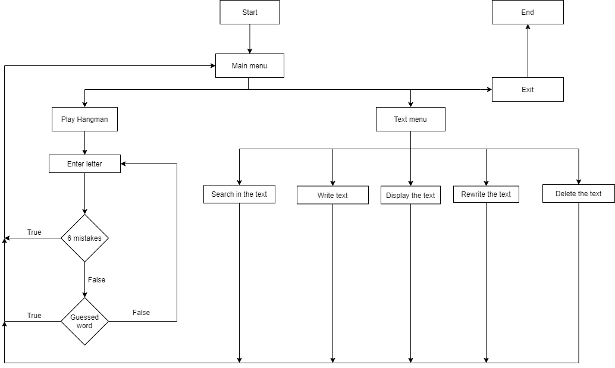

Figure 1

## Functions

|  |  |  |
| --- | --- | --- |
| Hangman.cpp | | |
| Function name | Description | Arguments |
| init | This function is of type void, it does not have a return type. Executes multiple functions, necessary for the game’s existence, like defining the words for guessing, the different stages of the hanging man, and the vector of available letters. | none |
| mainHangmanMenu | A function that returns nothing and make the final events |  |
| displayHangman | A function that returns number from type GAME_STATUS and display the Hangman game interface. | Mistakes – an integer that is used to count the mistakes made playing the hangman  Word – string that refers for the randomly generated word |

|  |  |  |
| --- | --- | --- |
| Search.cpp | | |
| Function name | Description | Arguments |
| extractData | This function is of type void and does not return a value. It opens a file called “searchData.txt" and extracts its contents in the Data string | Data – a string, which is a pseudonym used for storing the extracted data. |
| findSentence | This function is of type void and does not return a value. It searches for each sentence that contains the keyword and prints all of the result sentences on the screen | Text – string argument, which contains all of the text in searchData.txt  Word – string, which contains the keyword that is searched. |
| addToData | This function is of type void and does not return a value. It appends every new peace of info that the user enters in the console to the old data file. | Data – string that refence for the data in “searchData.txt". |
| displayFormatedText | This function is of type void and does not return a value. | Text – string argument, which contains all of the text in searchData.txt |